Parent Questionnaire
We completed the parent questionnaire electronically this year via Microsoft teams. Codes were shared at parents evening and devices available on the evening. The QR code was sent home with reports for those parents unable to attend the parents evening and reminders and the link sent on Seesaw. 58 questionnaires were completed.
The results were very positive with 95% of parents either agreeing or strongly agreeing that:
- The school has high expectations for my child.
- My child feels safe at this school. (3 did not know)
- The school has high expectations for my child.
- The school supports my child’s wider personal development.
- There is a good range of subjects available to my child at this school.
Over 90% of parents felt
- My child is happy at this school. (3 did not know)
- The school makes sure its pupils are well behaved. (2 did not know)
- The school supports my child’s wider personal development. (3 did not know)
- The school has high expectations for my child. (4 did not know)
- My child does well at this school.
- The school lets me know how my child is doing.
- The school supports my child’s wider personal development. (3 did not know)
- The school makes me aware of what my child will learn during the year. (2 did not know)
My child has been bullied and the school dealt with the bullying quickly and effectively.
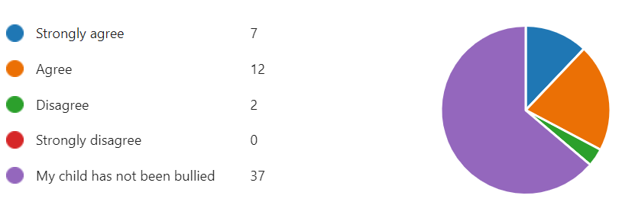
All bar one parent felt that if they had raised any concerns with school they have been dealt with properly.
81 % felt their child could take part in clubs and activities at this school, 9 did not know,
One parent felt we hadn’t been in contact prior to parents evening to say their child was not making expected progress. Subject teachers are expected to contact home if there is an ongoing issue in class.
All staff attend parents evening and parents are able to see any of their child’s teachers. If you feel there is more to discuss we would welcome a separate meeting.
We had a few parents who responded ‘don’t know’ to the questions. The new website is going live over the holidays and we hope this will enable parents to access information, along with the use of Seesaw which is currently our main form of contact. If you wish to add another contact to Seesaw please contact the office.
We have held a series of curriculum information parent coffee mornings in the Autumn term. These will be a regular feature. Termly information sheets are sent out on Seesaw and posted on the school website. The website can also be used to find more detailed information about what is being taught.
We are pleased that there were positive comments about the support families has received and the fact that our curriculum is adapted to meet your child’s needs,
‘My child's teachers have always been brilliant in this school and it's a pleasure to be support them and be supported in my child's learning journey.’
I could not be happier with how my son is all the staff are lovely and friendly and the activities and learning to my child’s own learning level is brilliant
I’d like Thank you all for the support. The staff at Bank View are warm and welcoming, listen to the parents and carers voices, adapting all the time to your child’s individual needs at school. Making sure they are enjoying their education at school.

Suggestions for parent workshops included
- Autism
- Sensory processing disorders
- ADHD
- Food aversion
- Supporting Independence
- Behaviours and social skills.
- Support for puberty

The Learning mentors and educational psychologists run parent coffee mornings, we will also look to engage guest speakers on the topics raised.
We are also working to achieve the Parent Partnership Award which looks at how we work with parents.

Reading
We have run courses on reading.
We will develop short videos to share with parents if they are unable to access information which will be posted on Seesaw for reference.
We are delighted that all bar one parent said they would recommend Bank View to another parent.

