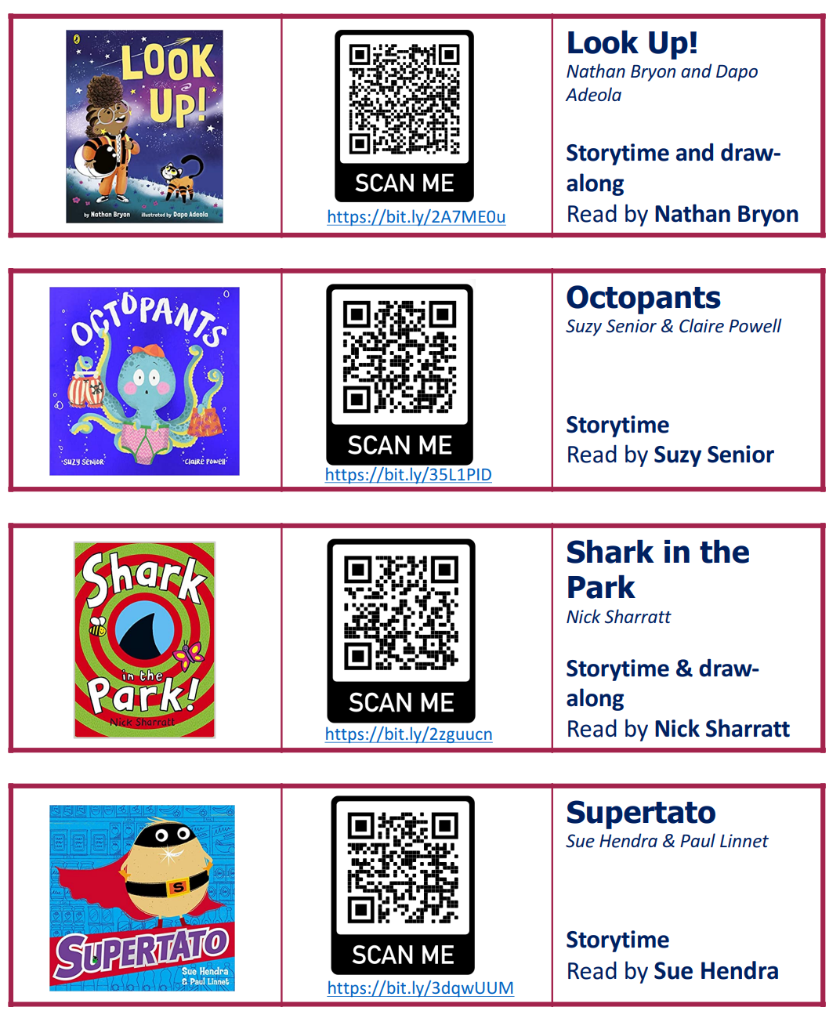Stage 1

Stage 1

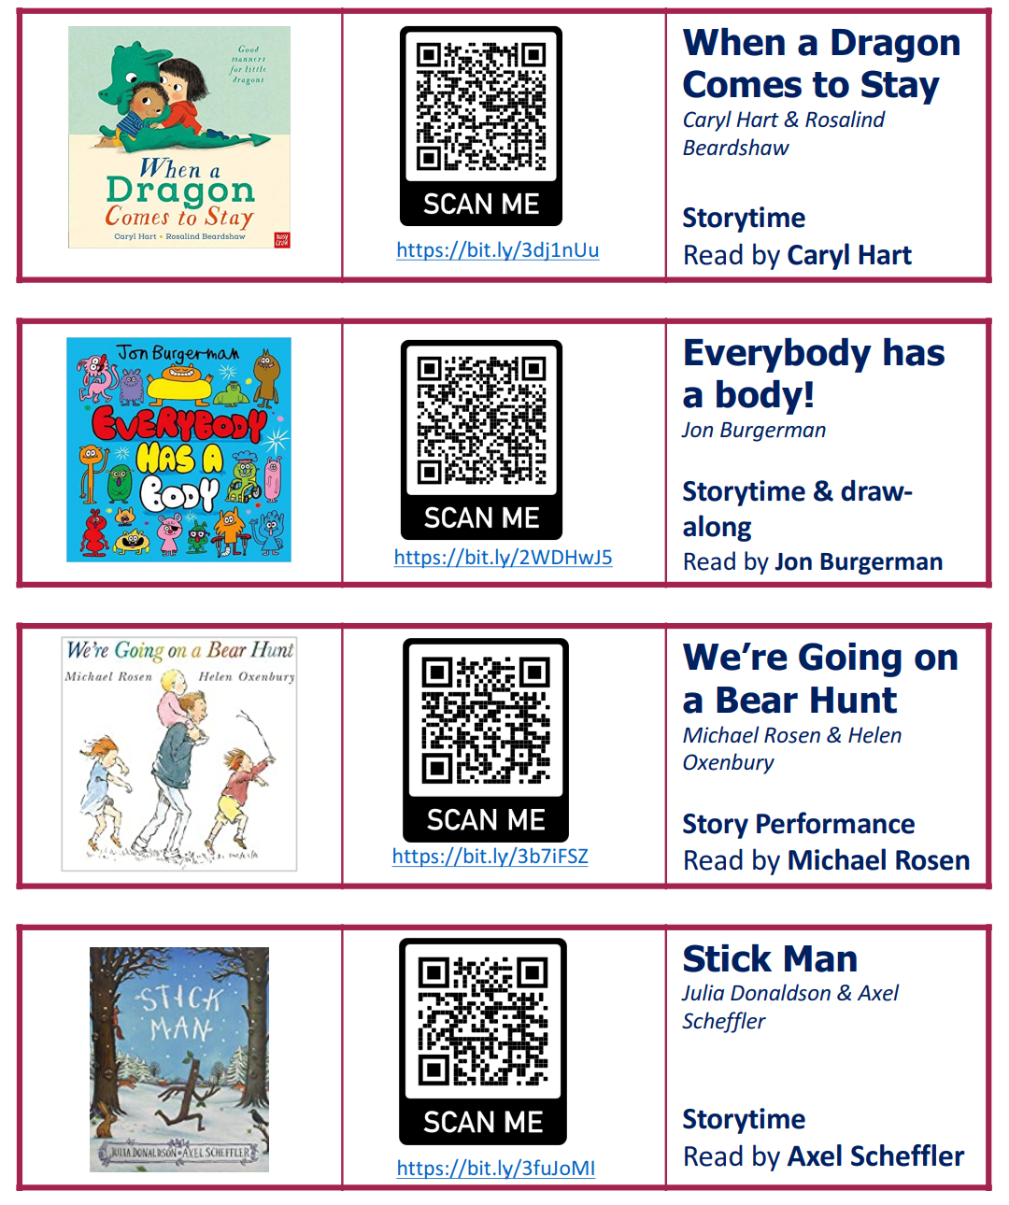

Stage 2

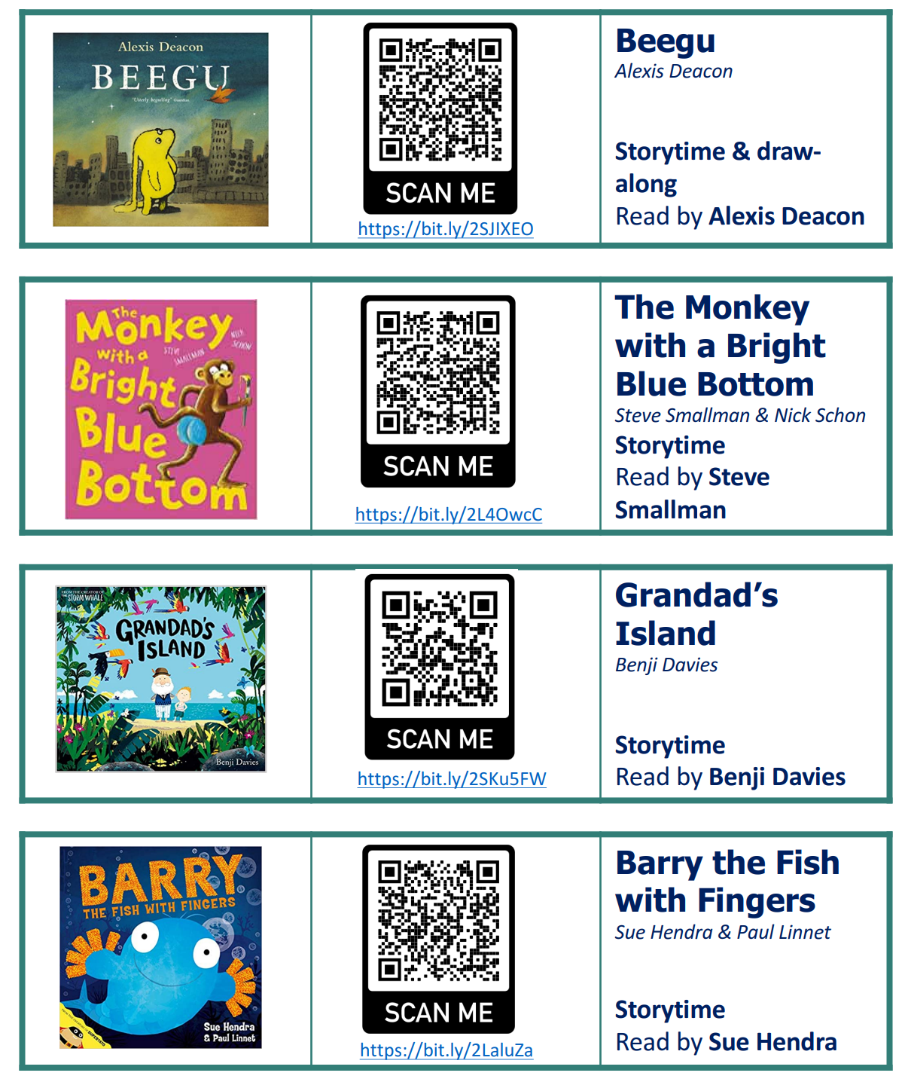

Stage 2

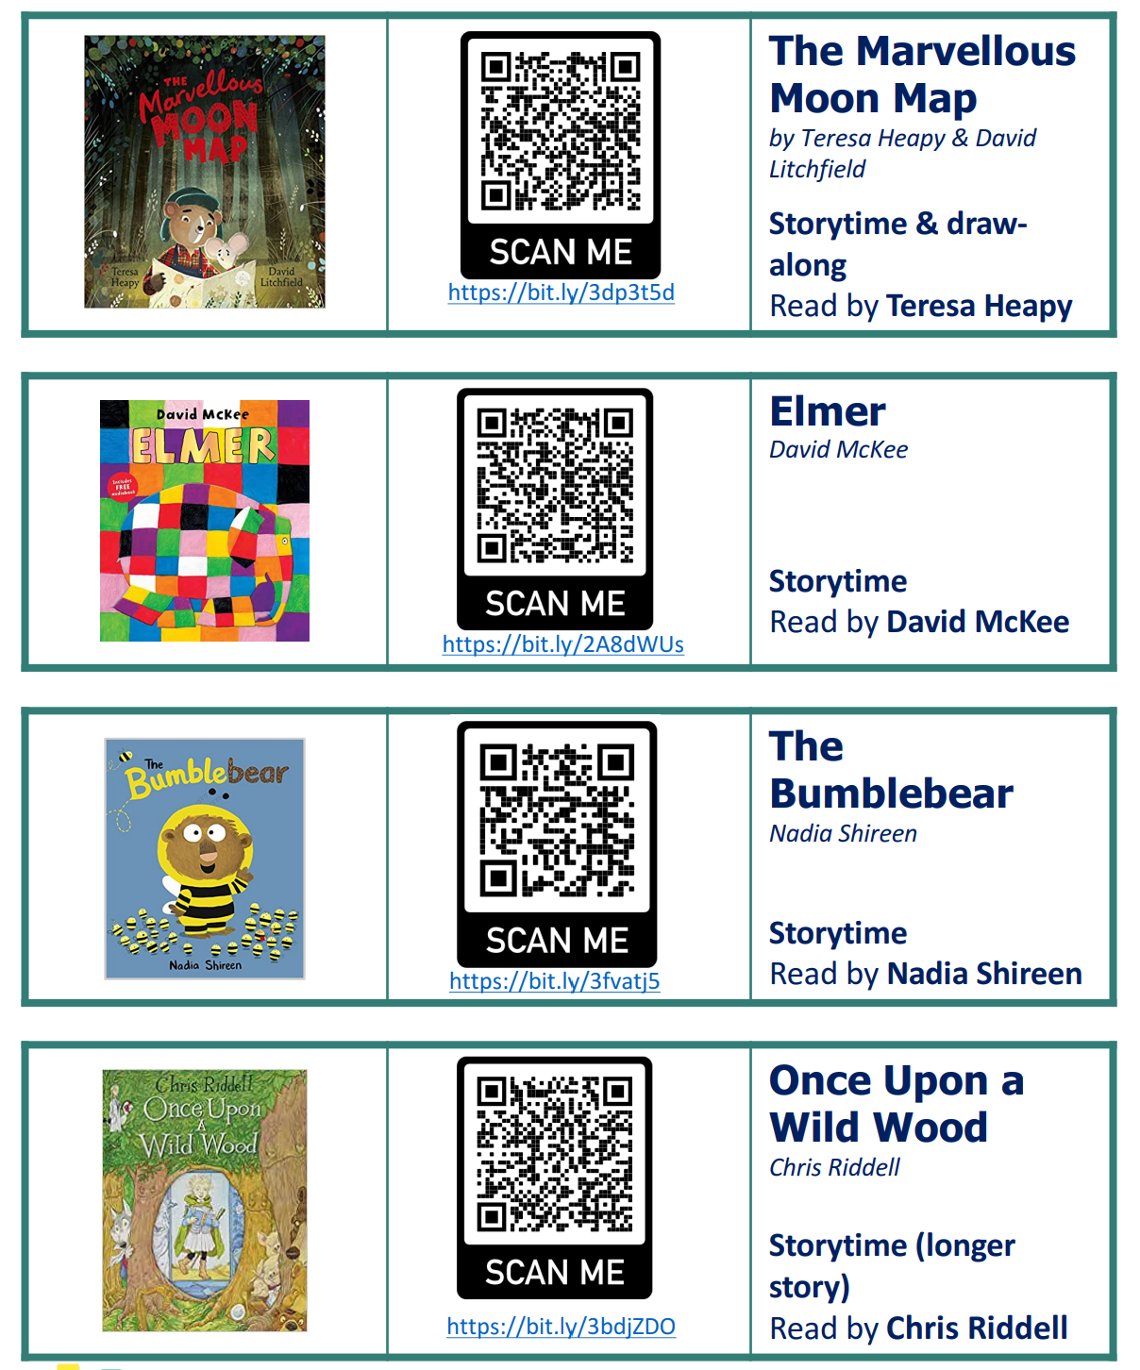

Stage 3

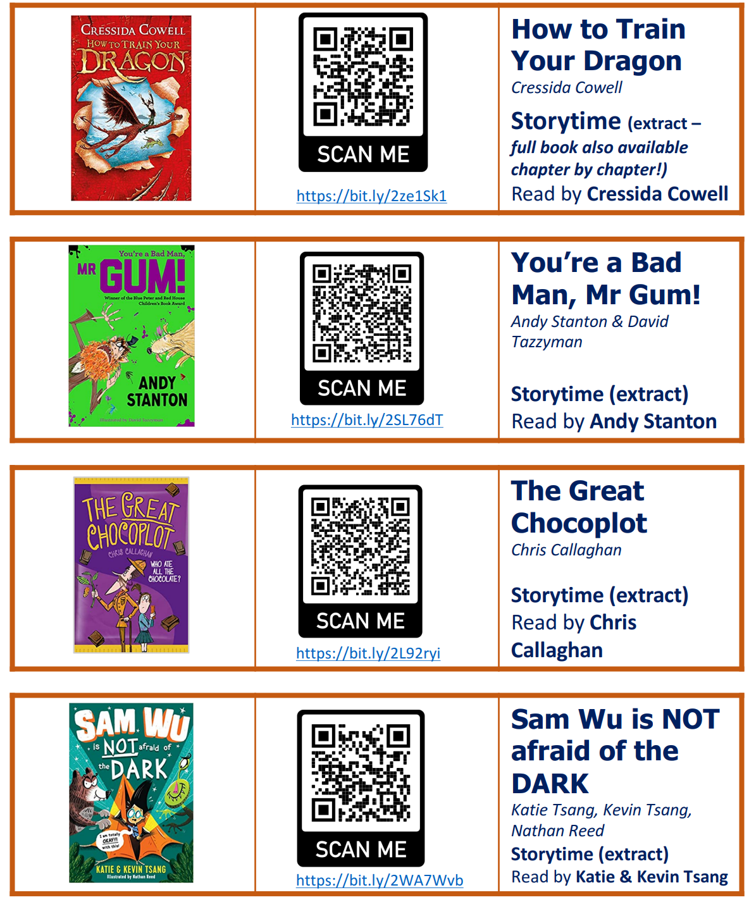

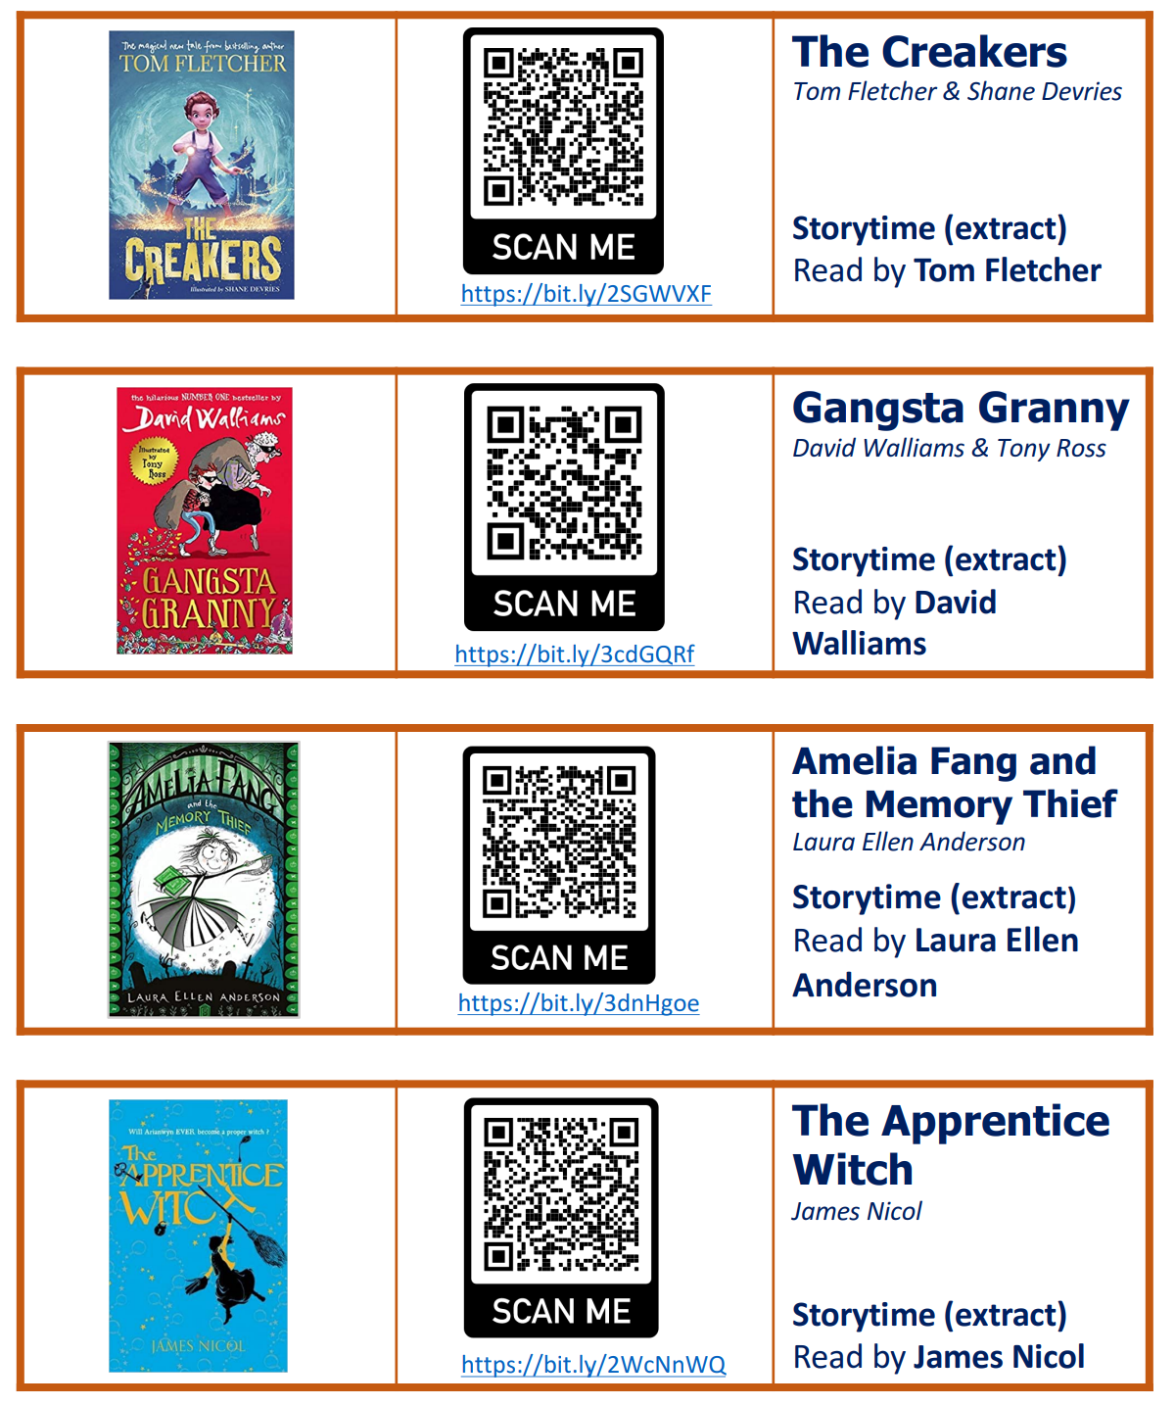Stage 3

Stage 4

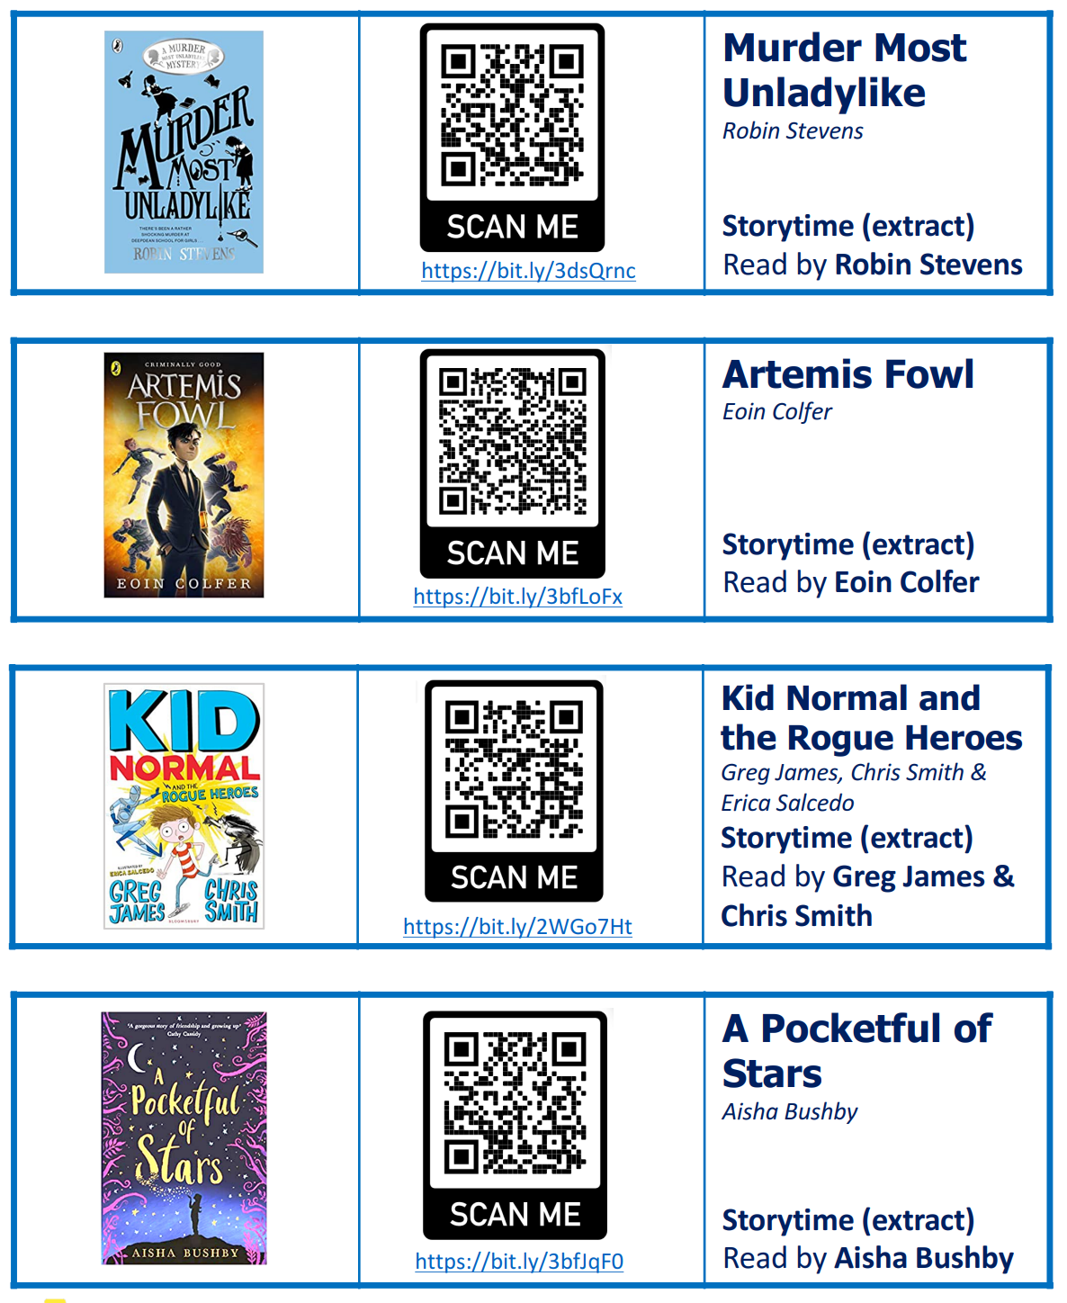

Stage 4

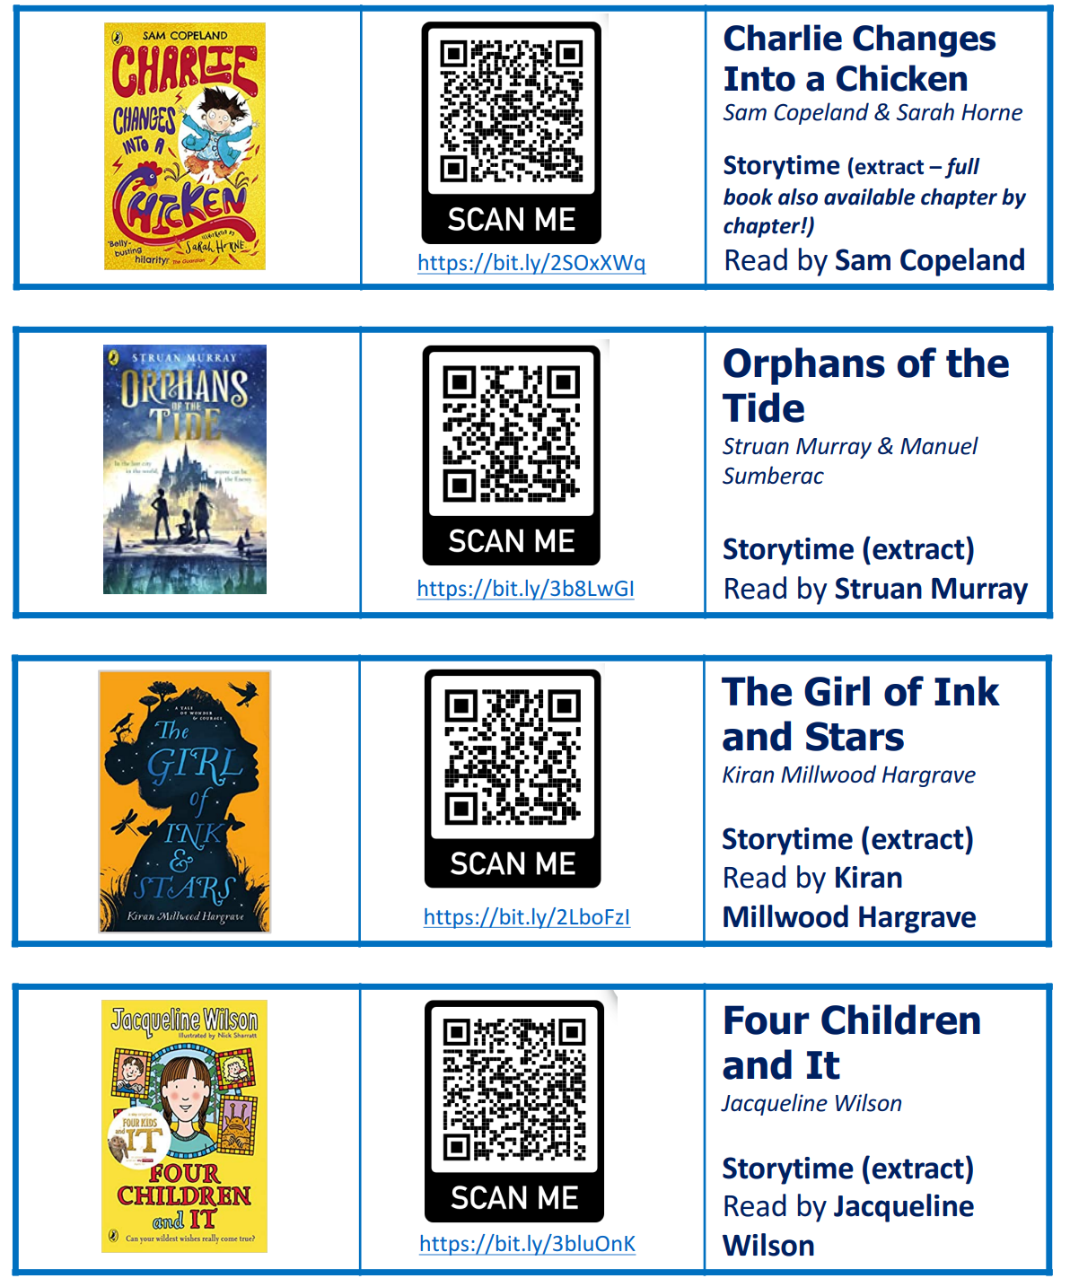

[Books for KS3 children aged 11-14 | School Reading List](https://schoolreadinglist.co.uk/category/reading-lists-for-ks3-pupils/) <https://schoolreadinglist.co.uk/category/reading-lists-for-ks3-pupils/>