Progress Report

**2023 -2024**

**Assessment**

Assessment data informs teachers how their learners are performing against our Bank View curriculum. This information is then used to support learners to progress and deepen their knowledge and promote understanding and develop skills.

The teachers assess against the three outcomes we use across the school:

The Teaching, Learning and Assessment and Feedback and marking policy have been updated by the curriculum team for September 2024.

**Primary**

Primary assessments are carried out via teacher assessments and diagnostic testing in class against the Bank View-adapted curriculum.

Over 90% of the learners are making progress either independently or with support in reading and maths and in writing over 85%.

All learners not making progress had personalised intervention to further support the learning.

For 3 of the learners identified as not making progress when supported we sought external advice and support from the LA for 2 and through the review process their school placement was changed for September 2024, the other has moved to our Base provision.

All children at Bank View Primary were working below the expected standard for the KS2 SATS so following discussion with staff and parents the decision was taken not to enter students for SATS in the academic year 2023 - 234

**Secondary**

Inhouse data

Assessment data collection points throughout the year enable teachers to identify learners not making expected progress with support and identify interventions in their subject areas. This is in discussion with the cluster leads. The names of any students not making progress in three or more subjects are supported with a Wave b plan for cognition and learning.

There is no difference in the progress made by those identified as disadvantaged and those not.

The progress data for girls is marginally less favourable than that for boys, this will be addressed through attendance initiatives as well as interventions.

We have used AEP placements to reengage a year 11 cohort with their learning and vocational interests. The proportion of these who are girls is greater than that across the school.

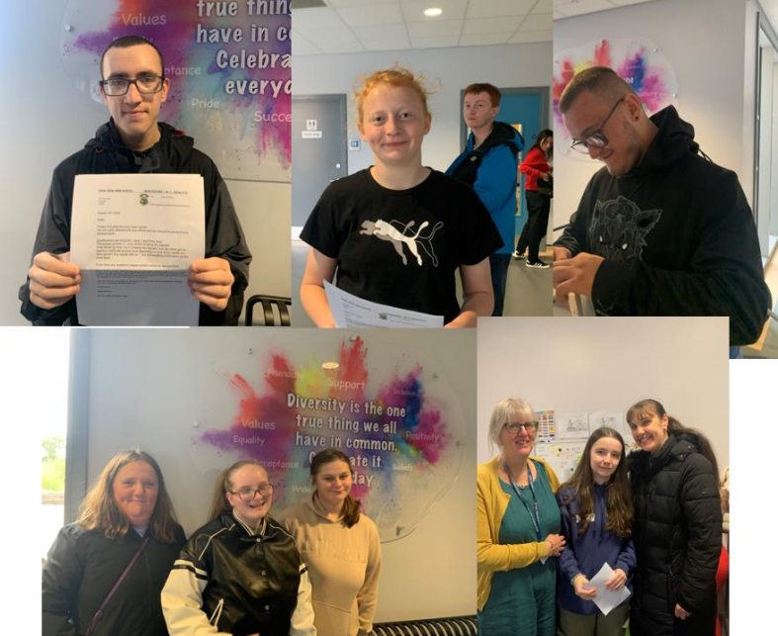**Key Stage 4**

On Thursday August learners from Year 11 came into school to collect their GCSE and entry level results. We have had another very successful year and we are extremely proud of our learners’s results and the efforts they put in and the barriers they overcame to achieve a broad range of qualifications.

This year we had 53 learners completing year 11. This is our largest cohort.

34 were in the main provision of the school following a secondary curriculum with subject specialist teachers. 10 students were in our base provision which caters for our most complex students. 9 attended Alternative Provision with 5 of these having a blended offer with on and off site tutoring / teaching.

**Main Secondary Provision**

*GCSEs*

13 students achieved a GCSE grade in 5 or more subjects including English and Maths.

1 student achieved 7 GCSEs including a 6 in Art and Design.

This year we broadened our offer by offering English literature as well as English language to an identified cohort.

*English and Maths*

All students accessing the main secondary provision achieved an English and maths qualification at entry level.

13 students sat and achieved a GCSE grade in English language.

11 students sat and achieved a GCSE grade in English language and Literature.

1 student achieving a four in both English qualifications.

All students achieved a functional skills English qualification at entry level

28 students sat GCSE Maths, 23 achieved a GCSE grade, 2 students at grade 4.

All students achieved an entry level maths qualification.

4 students achieved a functional skills maths qualification at level 1

*Science*

32 students achieved a science qualification.

13 were entered for and achieved a double GCSE grade in science synergy.

22 achieved entry level science

*Computing/IT Functional Skills*

30 students achieved an ICT Users award at either entry level 2 or 3.

A digital functional skills qualification was introduced at entry level 3 and level 1. 5 students achieved entry 3 and 3 Level 1.

*Art*

30 students achieved a GCSE qualification in Art and Design. Of these 47% were a grade four or above.

*Food Nutrition, Graphics and DT*

6 students achieved a GCSE in Food and Nutrition. 26 students achieved a Creative Media entry level.

*PE*

32 students achieved an entry level in PE. With 72% at entry level 3.

*Options*

Through their option choices students achieved entry level, level 1 and level 2 in subjects including MFL (Spanish), Sports Leadership, Performing Arts, Home Cooking, Construction, Humanities, Horticulture and Preparing for the World of Work (Childcare).

**Base Provision**

Students completed a Further Learning for Employment Qualification at either entry level 1 or 2. The qualification is designed to cover communication and interaction, life and independence skills, ICT skills and art.

One student did not attend school or take up our alternative offers.

Of the nine attending school 8 students achieved both an entry level English and maths qualification,

*Functional Skills*

5 students achieved an Functional Skills entry level in English and maths

**AP**

3 achieved GCSE art and Design.

All achieved a maths qualification

6 achieved functional skills entry level English and maths

All were entered for Functional skills English with 7 completing all three strands and two completing 2 of the 3 strands.

2 students achieved BTEC work skills qualifications at entry 3 and Level 1.

One student completed work experience placement at a Fisheries and achieved entry 2 Further learning qualification, FS Maths and a coaching qualification.

We used a tutoring company to provide 1:1 support for English, maths and

personal development.

**Destinations**

Took up a place in We have 2 students who have not taken up a college placement. We supported them with a range of visits to different settings and continue to support them and the families. Both have been referred to the NEAT team

**Post 16**

This year for the first time we offered GCSE resists in Maths and English, one student achieving a 4 in maths and another a 5 in English language.

Both subjects were offered as after school clubs with school supporting transport.

This years leavers destinations show our preparation for adulthood and college has been successful with all bar one beginning a college place.

The introduction of Digital Functional Skills enabled student to achieve a further qualification in ICT.